Payeer for CMS WHMCS 6.2

Copy the “modules” folder via FTP client in the site root with the replacement of files if required.

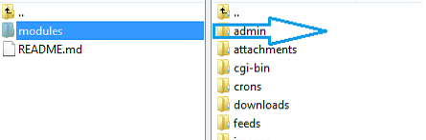

In the admin panel go to "Setup → Payments → Payment Gateways"

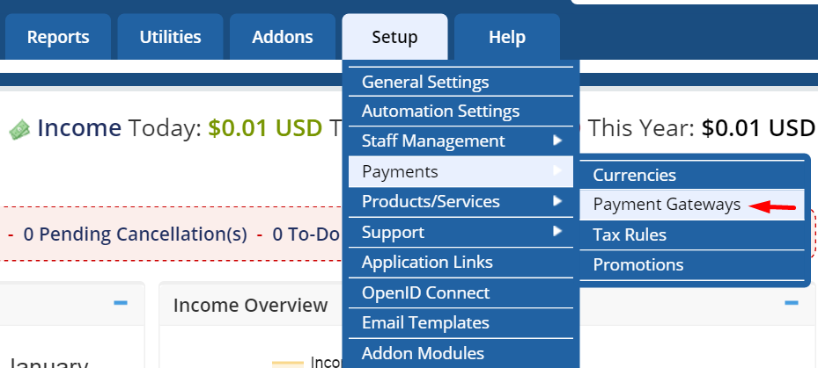

Tab All Payment Gateways

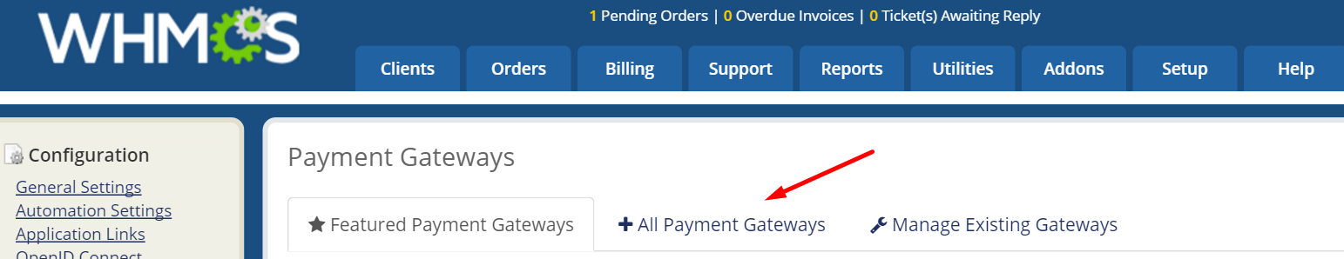

Among the available payment systems, locate and click on Payeer.
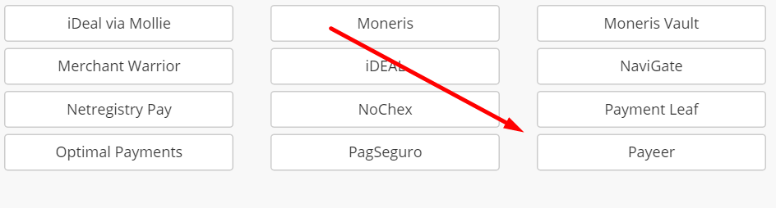
Specify the parameters of the payment system.
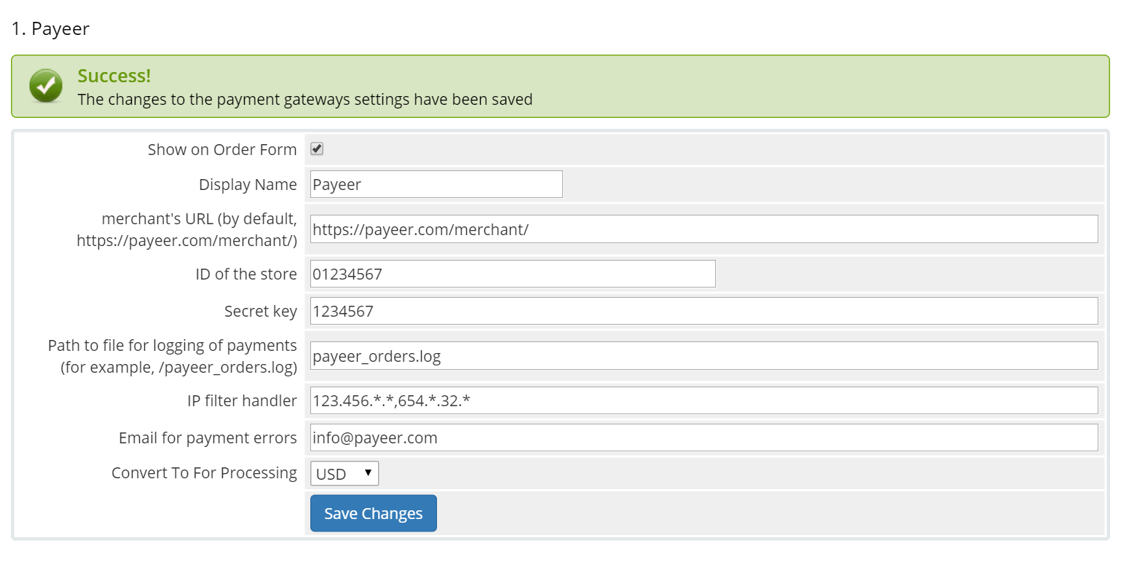
Be sure to fill in:
merchant’s URL: the default path to the payment https://payeer.com/merchant/
ID of the store: id of your store in the system Payeer.com (can be found in the personal сabinet).
Secret key: the secret key of your store, also issued to you when registering in the system.
Journal: if you specify the path to the file logging, you will be recording information about payments via Payeer.
IP filter handler: You can specify the list of all trusted ip addresses of servers, separated by commas. You can also specify a mask instead of the ip address. If the field is empty, checking for trusted ip addresses is not implemented.
For example:
192.168.71.87, 192.165.83.17, 192.178.34.15
Or 192.*.71.87, 192.165.83.*, 192.*.34.15
Or *.*.*.* - доступны все ip-адреса

Email for payment errors: enter your email address to receive notices in the event of an error of payment. The letter will state the reason and basic information about the payment.
Click "Save Сhanges".
Then, enter the URL address in the “account Payeer → Merchant → Settings”
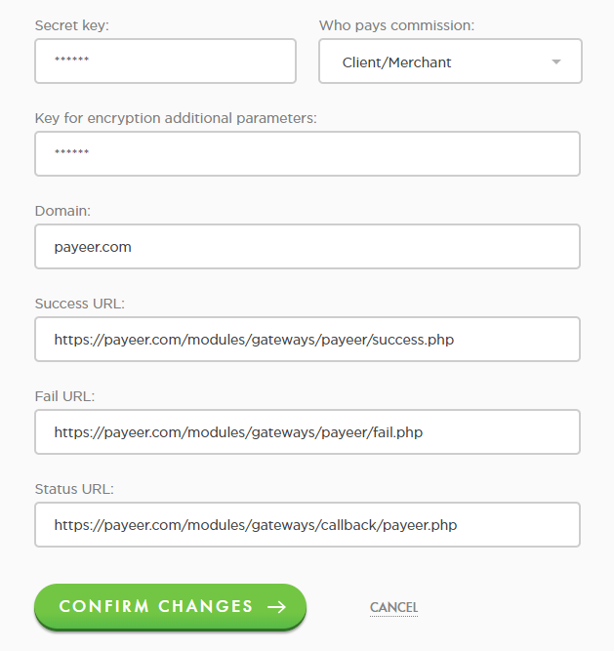

Success URL:
http:// *****/modules/gateways/payeer/success.php
Fail URL:
http:// *****/modules/gateways/payeer/fail.php
Status URL:
http:// *****/modules/gateways/callback/payeer.php
Where * * * * * is your domain.
Confirm changes.
Payeer module for WHMCS CMS 6.2 configured.

